**Name: ______________________________ Date: __________________**

**ATAR 12 HUMAN BIOLOGY**

**ATHBY Task 1: In class Validation Quiz**

1. Using only the materials you will submit for your write-up, complete the discussion. (12 marks)

2. Write a conclusion that summarises the main finding(s) of the experiment. (2 marks)

3. With reference to your results:

a) Draw and correctly label (including the types of neurons) the pathway that controlled your response

during the investigation. (4 marks)

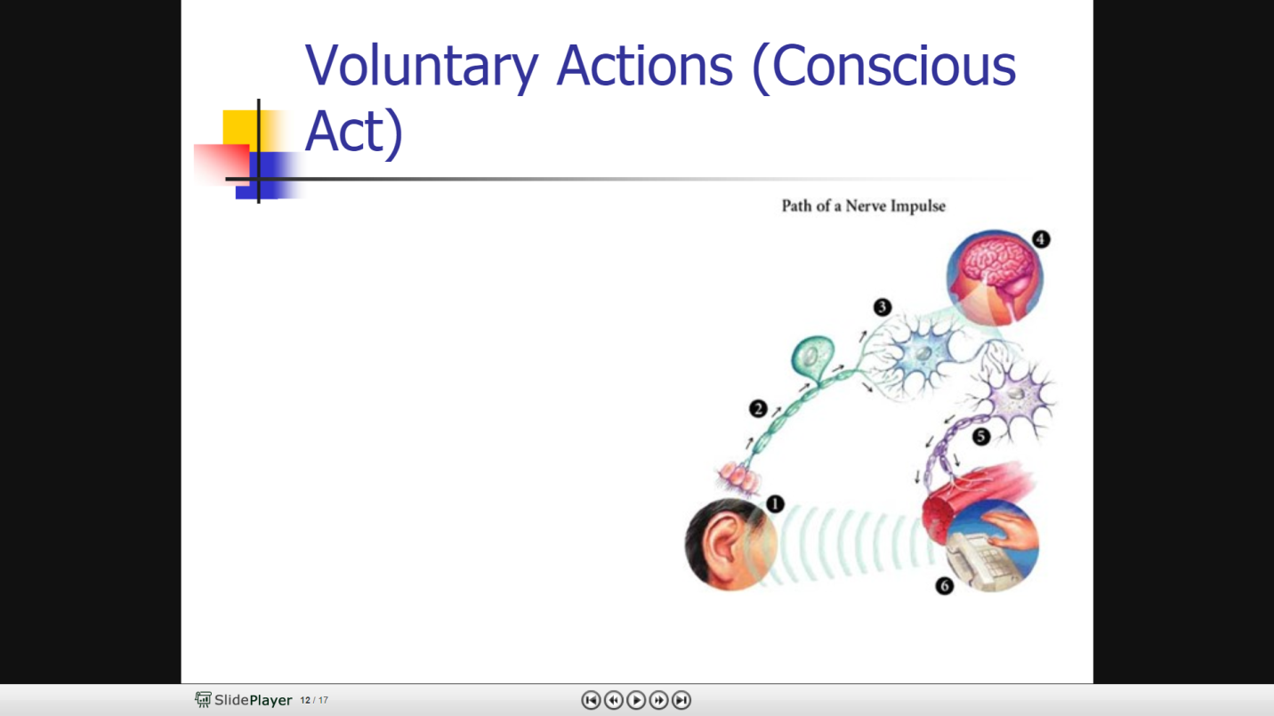One possible mark for each of the below used to give a coherent pathway:

* Stimulus detected by receptor
* Unipolar/Sensory neuron carries message to cerebrum
* Message processed in the appropriate area
* Interneuron relays message to motor neuron
* Motor neuron carries message to motor end plate
* In the effector
* Movement results

        b) Draw and correctly label (including the types of neurons) a spinal reflex arc. (4 marks)

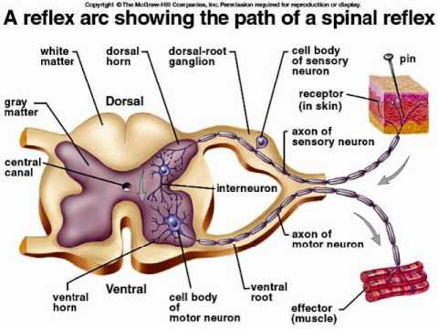

*Any 4 of the following structures labelled:*

*Stimulus*

*Receptor*

*Sensory/Unipolar/Afferent neuron*

*Cell body in dorsal root*

*Interneuron/connector neuron/relay neuron/bipolar*

*Located in grey matter of spinal cord*

*Motor neuron/multipolar/efferent neuron*

*Ventral root contains myelinated axons*

*Motor end plate*

*Direction of flow*

        c) Compare and contrast these two methods of nervous control of movement. (4 marks)

|  |  |  |
| --- | --- | --- |
|  | **Response** | **Spinal Reflex Arc** |
| Speed | Slower | Instantaneous |
| Neurons | Unipolar/Sensory – Interneuron/Connector/Bipolar – Motor/Multipolar | Unipolar/Sensory – Interneuron/Connector/Bipolar – Motor/Multipolar |
| Location of interneuron | Brain – grey matter | Spinal cord – grey matter |